**SAVEETHA SCHOOL OF ENGINEERING**

**CLASS ASSESSSMENT**

**NAME: S.JAYASHREE**

**REGNO:192121153**

1. #include<stdio.h>
2. #include<string.h>
3. int main(){
5. int i,j,rows,space;
6. printf("enter number of rows:");
7. scanf("%d",&rows);
8. for(i=rows;i>=1;i--){
9. for(space=0;space<rows-i;space++)
10. printf(" ");
11. for(j=i;j<=2*i-1;j++)
12. printf("*");
13. for(j=1;j<i-1;j++)
14. printf("*");
15. printf("\n");
17. }
18. return 0;
19. }

Output:

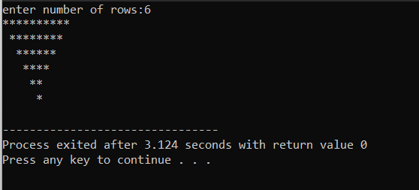

2. #include<stdio.h>

int main(){

int i,j,n;

printf("enter number of rows:");

scanf("%d",&n);

for(i=1;i<n;i++){

for(j=0;j<n;j++){

printf("*");

}

printf("\n");

}return 0;

}

Output:

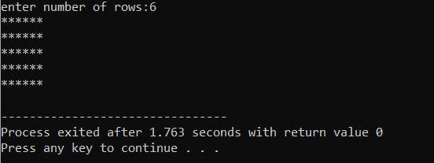

3. #include<stdio.h>

#include<conio.h>

int main()

{

int m,n,k,i;

printf("enter the start number:");

scanf("%d",&m);

printf("enter the end number:");

scanf("%d",&n);

printf("enter the skip number:");

scanf("%d",&k);

for(i=m;i<=n;i+=k){

printf("%d\t",i);

}

return 0;

}

Output:

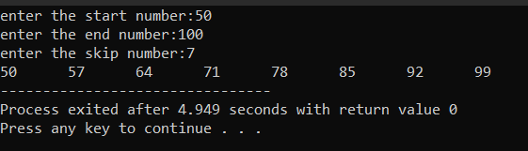

4.

#include<stdio.h>

#include<string.h>

int main(){

char word[60];

int n,i;

printf("enter the word:");

scanf("%s",word);

n=strlen(word);

printf("reversed word\n");

for(i=n-1;i>=0;i--){

printf("%c",word[i]);

}return 0;

}

Output:

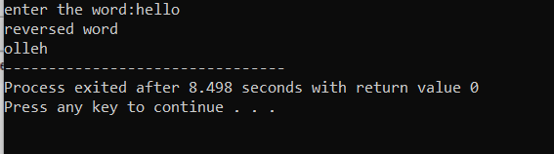

5.

#include<stdio.h>

int main()

{

int a[10][10],b[10][10],c[10][10],n,i,j,k;

printf("enter the value of n (n<=10)");

scanf("%d",&n);

printf("enter the element of matrix -a:\n");

for(i=0;i<n;i++)

{

for(j=0;j<n;j++)

{

scanf("%d",&a[i][j]);

}

}

printf("enter the element of matrix-b:\n");

for(i=0;i<n;i++)

{

for(j=0;j<n;j++)

{

scanf("%d",&b[i][j]);

}

}

for(i=0;i<n;i++)

{

for(j=0;j<n;j++)

{

c[i][j]=0;

for(k=0;k<n;k++)

{

c[i][j]+=a[i][k]*b[k][j];

}

}

}

printf("the product of two matrix is ; \n");

for(i=0;i<n;i++)

{

for(j=0;j<n;j++)

{

printf("%d\t",c[i][j]);

}

printf("\n");

}

return 0;

}

Output:

